------------------------------------------------------------------------------------------------------------

LAB ASSIGNMENTS: Spring Boot 3.x

- Spring boot Dependency Injection
- Spring boot AOP
- Spring boot REST CURD operation
- 1. Proper ResponseEntity should be returned as per requirements
- 2. study http status code and return appropriate status code
- 3. Custom validation for bookType: IT, MGT
- Spring Boot JDBCTemplate
- Spring Boot JPA Integration
- Spring data with mysql
- Spring data pagination and custom quaries
- Spring boot Logging and logging customization
- spring boot profile
- spring boot actuator
- Spring boot caching (In memory)

Create BookStore application by following 3 tier architecture with following dao server layer

1. Create bookstore application

Design persistance layer:

com.training.model.persistance

public class Book {
private int id;
private String isbn;
private String title;
private String author;
private double price;

//getter setter , ctr
}

public interface BookDao {
public List<Book> getAllBooks();
public Book addBook(Book book);
public void deleteBook(int id);
public void updateBook(int id, Book book);
public Book getBookById(int id);
}

@Repository
public class BookDaoImp implements BookDao {
private static Map<Integer, Book> booksMap = new HashMap<Integer, Book>();
private static int counter = 0;
static {
booksMap.put(++counter, new Book(counter, "ABC123", "Head first Java" , "Katthy", 600));
booksMap.put(++counter, new Book(counter, "ABC723", "Servlet jsp Java" , "Katthy", 700));
}

@Override
public List<Book> getAllBooks() {
return new ArrayList<Book>(booksMap.values());
}

@Override
public Book addBook(Book book) {
book.setId(++counter);
booksMap.put(counter, book);
return booksMap.get(counter);
}

@Override
public void deleteBook(int id) {
booksMap.remove(id);
}

@Override
public void updateBook(int id, Book book) {
booksMap.put(id, book);
}

@Override
public Book getBookById(int id) {
return booksMap.get(id);
}

}

Design Service layer:

com.training.model.service

public interface BookService {
public List<Book> getAllBooks();
public Book addBook(Book book);
public void deleteBook(int id);
public void updateBook(int id, Book book);
public Book getBookById(int id);
}

@Service
public class BookServiceImp implements BookService {

@Autowire
private BookDao dao;

@Override
public List<Book> getAllBooks() {
return dao.getAllBooks();
}

@Override
public Book addBook(Book book) {
return dao.addBook(book);
}

@Override
public void deleteBook(int id) {
dao.deleteBook(id);
}

@Override
public void updateBook(int id, Book book) {
dao.updateBook(id, book);
}

@Override
public Book getBookById(int id) {
return dao.getBookById(id);
}

}

CORE SPRING: AOP

In lab DI you have created book application, now we require to log information while somebody deleted book
Improve the application using AOP to applying logging, You can create an custom annotation such as @Loggable and put it one deleteBook method. Now if book is deleted information about deleted book should added to log file in aop way.
You can use code snippet mentioned below.

@Service
public interface BookService implements BookService {
@Autowire
private BookDao dao;
public List<Book> getAllBooks(){
}
public Book addBook(Book book){}

public void deleteBook(int id){
// if somebody delete book we need to log information in log file using AOP
}
public void updateBook(int id, Book book){}
public Book getBookById(int id){}
}

Custom annotation

@Retention(RetentionPolicy.RUNTIME)
@Target(ElementType.METHOD)
public @interface Loggable {

}

Improve application design by AOP

import org.aspectj.lang.ProceedingJoinPoint;
import org.aspectj.lang.annotation.Around;
import org.aspectj.lang.annotation.Aspect;
import org.aspectj.lang.reflect.MethodSignature;
import org.slf4j.Logger;
import org.slf4j.LoggerFactory;
import org.springframework.stereotype.Component;
@Component
@Aspect
public class MethodLogger {
private static final Logger logger=LoggerFactory.getLogger(MethodLogger.class);

@Around("@annotation(Loggable)")
public Object around(ProceedingJoinPoint point) throws Throwable {
long start = System.currentTimeMillis();
Object result = point.proceed();
logger.info("start "+MethodSignature.class.cast(" Method takes " +(System.currentTimeMillis() - start));
return result;
}
}

Spring REST
In this lab you need to support REST endpoint for book application.

Take the help of given code snippet. Note use of @RestController and @ RequestMapping annotation.

1. Provide support for CURD operation
2. Proper ResponseEntity should be returned as per requirments
3. study http status code and return appropiate status code

Spring REST Validation
In this lab you need to apply validation support to REST endpoint for book application.

In case validation fail user must get correct status code 400 with proper validation failure message
Validation message must not be hard coded

Spring JDBC

In lab AOP you have created book application, now we require to replace persistance layer with jdbc. Note that service layer should
remain uneffected by the change.

@Service
public interface BookService implements BookService {

@Autowire
private BookDao dao;

public List<Book> getAllBooks(){
}
public Book addBook(Book book){}

public void deleteBook(int id){

}
public void updateBook(int id, Book book){}
public Book getBookById(int id){}
}

Implement crud method using jdbc, inject datasource in persistane layer, using xml and java configuration

Spring Hibernate/JPA
In lab Spring Jdbc you have created book application using JDBC, now we require to replace persistance layer with Hibernate. Note that service layer should remain uneffected by the change.

@Service
public interface BookService implements BookService {

@Autowire
private SessionFactory factory;

public List<Book> getAllBooks(){
}
public Book addBook(Book book){}

public void deleteBook(int id){

}
public void updateBook(int id, Book book){}
public Book getBookById(int id){}
}

1. Implement crud method using Hibernate, inject factory in persistane layer, using xml and java configuration
2. Implement crud method using spring-Hibernate ( reduce boilerplat code)
3. Apply declerative transaction management using @Transactinal annotation
4. Do experiments with different optionals available with @Transactinal annotation

Spring Data using MySql
In this lab you need to migrate to spring data using mysql. With spring data we dont have to write dao layer we just need to declare dao layer

Spring data custom configuration

Spring boot is higly customized framework, although spring boot automatically configure datasource, entitymanagerfactory etc but we can configure our bean along with transaction management, In this lab write custom configuration of these beans

Spring boot Logging and logging customization
In this lab customized spring boot to use log4j2 and do custom logging of a specific package

spring boot profile
Profiles in Spring Boot are a way to define different sets of configurations for your application depending on the environment it is being run in. For example, you might have one set of configurations for your development environment and another set of configurations for your production environment

Spring boot profile help us to use different configuration depending on dev,test and prod profile, using different database for different profile and switch profile without changing the code

spring boot actuator
Spring Boot's 'Actuator' dependency is used to monitor and manage the Spring web application. We can use it to monitor and manage the application with the help of HTTP endpoints or with the JMX.
In this lab apply spring boot actuator and monitor application with various endpoints

Spring boot caching (In memory)
Spring Boot Caching is a feature that allows you to store data in memory so that it can be accessed more quickly. This can improve the performance of your application by reducing the number of times that it needs to access the database or other slow storage mechanisms.

Spring boot Schedule Process
Spring Boot Scheduler is a feature of Spring Boot that allows you to schedule tasks to be executed at a specific time or with a certain frequency. This can be useful for automating tasks such as sending emails, generating reports, or processing data.

Spring boot JSP Integration
Spring Boot JSP integration is a way to use JSP (JavaServer Pages) with the Spring Boot framework. JSP is a technology that allows developers to create dynamic web pages. Spring Boot is a framework that makes it easy to create Java applications.
To integrate JSP with Spring Boot, you need to add the following dependencies to your project:spring-boot-starter-web, tomcat-embed-jasper, and jstl.

Spring boot RestTemplate
Spring Boot RestTemplate is a template class that simplifies the process of making HTTP requests. It provides a number of convenience methods for making GET, POST, PUT, and DELETE requests, as well as handling responses and exceptions

spring boot OpenFeign
Spring Cloud OpenFeign is a Java to HTTP client binder that makes it easier to write web service clients. It was originally created and released by Netflix as Feign and then moved to the open-source community renamed as Openfeign. Spring Cloud OpenFeign provides OpenFeign integrations for Spring Boot apps through auto-configuration and binding to the Spring Environment.

Spring boot testing

Spring Boot provides a number of utilities and annotations to help when testing your application. Test support is provided by two modules: spring-boot-test contains core items, and spring-boot-test-autoconfigure supports auto-configuration for tests.

Most developers use the spring-boot-starter-test “Starter”, which imports both Spring Boot test modules as well as JUnit, AssertJ, Hamcrest, and a number of other useful libraries.

The spring-boot-starter-test “Starter” contains the following provided libraries:

JUnit: The de-facto standard for unit testing Java applications.
Spring Test & Spring Boot Test: Utilities and integration test support for Spring Boot applications.
AssertJ: A fluent assertion library.
Hamcrest: A library of matcher objects (also known as constraints or predicates).
Mockito: A Java mocking framework.
JSONassert: An assertion library for JSON.
JsonPath: XPath for JSON.

Spring boot jacoco code coverage
Upon completing the writing of Unit Testing, it is essential to see how much the tests covered the code and identify areas that require additional testing. We do those things to make sure the application code is thoroughly tested and ready for deployment. Today I will introduce JaCoCo, a tool for generating code coverage reports for Java projects.

spring boot sonarqube
SonarQube is an open-source platform for continuous inspection of code quality. It performs automated code analysis and provides detailed reports on code quality, code coverage, and various code-related issues, including bugs, vulnerabilities, and code smells. Integrating SonarQube into a Spring project can help you maintain high code quality and detect issues early in the development process

Spring boot RestTemplate, OpenFeign

RestTemplate is a class in Spring that allows for client-side HTTP access.
It's a synchronous client that uses the Java.net.HttpURLConnection HTTP client library to
make RESTful requests to external APIs and services. RestTemplate provides templates for common scenarios by HTTP method, as well as generalized exchange and execute methods for less frequent cases. It also has methods for making GET, POST, PUT, and DELETE requests, as well as the ability to handle exceptions and responses.

OpenFeign is a declarative web service client. It makes writing web service clients easier. When calling other services using Feign, we don't need to write any code. We just need to create an interface and annotate it. It has support for OpenFeign and Jakarta JAX-RS annotations.

Spring boot RabbitMQ integration

RabbitMQ is an open-source messaging broker that allows communication between different software systems, services, and devices. It uses the Advanced Message Queuing Protocol (AMQP), a standardized communication protocol for scalable messaging. RabbitMQ is made up of broker processes that host exchanges for publishing messages and queues for consuming messages. It's often compared to a post office for applications and messages.

Spring boot Kafka integration
Apache Kafka is an open-source, distributed streaming platform that allows applications to publish, subscribe to, store, and process streams of records in real time. It's used to build real-time streaming data pipelines and applications. Kafka can handle data streams from multiple sources and deliver them to multiple consumers, and can reduce latency to milliseconds

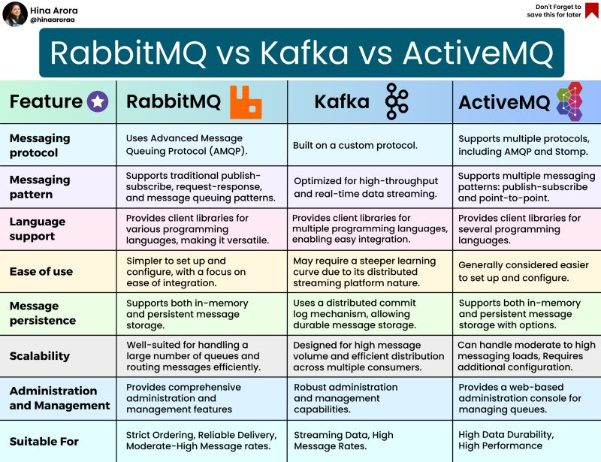

Spring security basics Auth
Spring Security is a framework which provides various security features like: authentication, authorization to create secure Java Enterprise Applications.Spring Security is a framework which provides various security features like: authentication, authorization to create secure Java Enterprise Applications.

Spring Security JWT Integration
JSON Web Token (JWT) is an open standard (RFC 7519) for securely transmitting information between two parties as a JSON object. This information can be verified and trusted because it is digitally signed. JWTs can be signed using a secret (with the HMAC algorithm) or a public/private key pair using RSA or ECDSA.
Although JWTs can be used for more than authentication, this is their primary use. Because they are digitally signed, they can be used to verify the identity of the issuer.

